EASTERN OPHTHALMIC PATHOLOGY SOCIETY
Washington DC
September 13-15, 2018

Khalid Bedaiwi, M.D. Adullah Alfawaz, M.D
Selwa Alhazzaa, M.D, PhD, Faisal Alqhtani, M.D Telephone: 00966536060320
Department of ophthalmology E-Mail: kbedaiwi@gmail.com
King Faisal Specialist Hospital
Riyadh, KSA

Intraocular T-cell lymphoma from a primary adrenal T-cell lymphoma.

Introduction

Primary intraocular lymphoma is the most common lymphoma in the eye in which the most common type is B cell lymphoma [1]. Intraocular non-B cell type is rare. It accounts only 1-3% of all lymphoproliferative lesions in the eye [2]. Most intraocular T cell lymphomas arise from metastatic systemic source which are known to have poor prognosis [3, 1]. Only few case reports and series have been described it [4, 5]. Intraocular manifestations of metastatic T cell lymphoma are rare [6]. It mostly presents with non-granulomatous anterior uveitis and vitritis [7]. Metastasis of systemic lymphomas usually occurs throughout blood to the uvea [1]. Other ocular manifestations include, yellowish subretinal infiltrates and posterior uveitis with or without optic nerve involvement [6]. Primary adrenal lymphoma (PAL) is an extremely aggressive and rare in which majority of them present as a large B cell lymphoma. Adrenal T cell is a very rare [8, 9]. Up to our knowledge, literature report only 5 cases of PAL, with only two cases of eye metastasis. This is a rare case of intraocular metastatic adrenal T cell lymphoma.

Case Report

A 71-year-old Saudi man known case of rheumatic heart disease, hypertension and chronic kidney disease, was admitted for workup of anemia and weight loss. Four months prior to admission, he noticed a gradual, painless decline in his vision of both eyes. He did not report any history of eye redness, photophobia, floaters, flashes or scotoma. There was no previous history of eye trauma or surgery. During systemic review of the patient, he reported history of raw milk ingestion.

His visual acuity was 6/200 on the right and 20/200 on the left, while his intraocular pressure was 13 and 15 mmHg in both eyes. His external exam and extra-ocular movements were normal. Pupils were both reactive to light, with no relative afferent pupillary defect (RAPD). Slit lamp examination of the right eye showed deep and quite anterior chamber (AC). Left eye exam showed a 3 mm pinkish hypopyon, iris pigments on the surface of the lens, and irregular pupil with posterior synechiae. A visually significant nuclear sclerotic cataract along with multiple corneal scars in both eyes were obscuring the dilated fundus exam.

Extensive systemic work-up for infectious and inflammatory etiologies of possible panuveitis was performed. 3 sets of Blood, sputum and urine culture were all negative. Repeated cultures for acid fast bacilli were negative. Brucella titer was negative for brucellosis infection.

B-Scan showed flat retina, no vitritis or subretinal infiltrate. Fundus photo and FFA were done and had very poor view probably due to very dense cataract. UBM showed floating cells in the AC and hypopyon.

Multiple radiologic investigations were done. Chest x ray showed signs of pulmonary edema otherwise unremarkable for TB or sarcoidosis. Liver US showed heterogeneous liver with no definite mass lesion noted. CT CAP showed large heterogeneous left adrenal mass, with finding that is suspicious for invasion, consistent with malignancy.

We started the patient on prednisolone acetate drops QID, cyclopentolate drops TID. A follow appointment was given. On 15th of April 2018, the patient was managed with cataract surgery of the left eye and intraoperative diagnostic paracentesis was successfully done.

Microscopic examination of the left aqueous fluid showed atypical lymphoid cells with blastoid morphology and immunohistochemical (IHC) staining that is consistent with T-cell lymphoma. US guided biopsy was taken from the adrenal mass and microscopic examination which showed infiltration with atypical small to medium lymphoid cells with blastoid features. The tumor cells were positive to CD3 and CD34 while negative to CD20. Along with other extensive immunohistochemical battery the diagnosis of T-cell lymphoma is further confirmed. PET/CT scan done and showed high uptake in scrotum and testicles. US of scrotum and testicles showed involvement by testicular lymphoma. Bone marrow biopsy showed no evidence of metastasis.

Flow cytometry analysis of the aqueous fluid demonstrated a positive lymphocytic subpopulation of CD5, CD3, CD2, CD8 and CD56 markers, but aberrant loss of CD4 and CD7 and no expression of CD10 and CD34. The alpha and beta TCR were positive but gamma was negative. The overall features were consistent with T-cell lymphoma.

On 2 weeks post op follow up, visual acuity was CF OU at 3 feet. Intraocular pressure of both eyes was normal. Anterior segment exam showed reforming pinkish hypopyon in the left AC and IOL was in place. Dilated fundus exam of the right eye showed hazy view due to cataract. Left eye fundus exam showed whitish retinal infiltrate in multiple areas.
Hemato-oncology team were consulted to start treatment. Since there was retinal infiltrate, they recommend to do lumber puncture and PET scan of the brain and orbit to rule out CNS involvement.
Our patient was treated for T-cell lymphoma with CVP (cyclophosphamide, prednisolone and Oncovin [vincristine]). PET scan of the brain and orbit showed increase uptake in right nasal and eithmoidal sinuses, most likely lymphoma related. LP was done and CSF was negative. Intrathecal treatment was given with cytarabine and hydrocortisone. Local radiation treatment was given to orbits and testicles.
After two cycles of chemotherapy, the patient condition was deteriorating he had rapid ventricular response and atrial fibrillation. The patient was stabilized and transferred to MICU. Because the patient were in MICU, ophthalmic bedside follow ups were continued and findings were the same as last follow up. Couple of days, while the patient is in the ICU, suddenly he collapsed, became unresponsive and impalpable pulse. CPR and ATLS protocol started. Patient was intubated, deeply comatose, GCS 6/15. Patient developed sepsis, treated with antibiotics. Because of his clinical condition, chemotherapy and radiation were on hold, Patient continued to deteriorate, GCS became 3/15, and he put on full DNAR. Unfortunately on 1st of July, patient died in the hospital.

Discussion

Adrenal T cell lymphoma is rare disease and more common in men above 60 years old [10]. Most of the time, it affects both adrenal glands 60% to 75% [8, 9]. The main clinical symptoms are lumber pain or fever and weight loss. [8, 11]. Most Intraocular metastasis are B cell in origin. Intraocular T cell metastatic lymphoma is very rare [12], and clinically it is very difficult to distinguish intraocular T cell from B cell lymphoma [13]. Nearly, all patients have vitreoretinal involvement [13]. Metastatic B cell lymphoma usually have uveal involvement, in contrast to metastatic T cell lymphoma, which usually presents with anterior uveitis (71%) and subretinal/retinal infiltrate (57%) [13]. in literature, only few case reports and series have document this [4, 5].
In our patient, the histologic appearance of the aqueous tap fluid from the tap reveled atypical lymphoid cells with blastoid morphology consistent with diagnosis of T cell lymphoma. Flowcytometry analysis of the aqueous fluid demonstrated a positive lymphocytic subpopulation of CD5, CD3, CD2, CD8 and CD56 markers, but aberrant loss of CD4 and CD7 and no expression of CD10 and CD34. The alpha and beta TCR were positive but gamma was negative. The overall features are consistent with T cell lymphoma.
Our patient was unusual in that the metastases to the eyes were intraocular is not the primary origin. In general, metastases to the eye and ocular adnexa from T-cell lymphomas are uncommon relative to B-cell lymphomas [14-17].
To our knowledge, we are the first in Saudi Arabia who report intraocular metastatic T cell arising from adrenal gland. In our patient, the lymphoma masqueraded clinically as anterior uveitis with psudohypopon. Although, we could not do autopsy for the left eye due to our hospital policy, lymphoma cells was clinically invading the anterior chamber and retinal layers causing anterior uveitis with psudohypopon and subretinal infiltrate. Unlike B-cell lymphomas which usually spread to the uvea tissue [18].
Sampath et al. and Sfaxi et reported a case of 33 years old male with bilateral adrenal T cell lymphoma who presented with weight loss, fever and vomiting. No metastasis was detected. Patient was successfully treated with chemotherapy [12, 19].
Also, Pimentel et al. reported 42 years old male with large, bilateral adrenal extranodal T cell lymphoma who same symptoms as the previous man. CSF was positive for malignant cell and metastasis to rectus muscle sheath of both eye. Patient was expired after 4 months [20].
Karthik Bommannan reported a case of 26 years old male with bilateral adrenal T cell lymphoma who presented with weight loss and blurred vision. Aqueous aspirate from the psudohypopon of the right eye showed infiltration of lymphoid cells. Patient expired due to intra-abdominal hemorrhage [21].
In conclusion, intraocular metastatic adrenal T cell lymphoma is rare condition. The diagnosis is essentially histological and it is important to obtain a biopsy early on in the diagnostic workup of adrenal masses. Also analysis of the aqueous tap in a patient who presented with hypopyon is beneficial. Patients with systemic lymphoma should be referred to an ophthalmologist to evaluate for intraocular and periocular involvement. We need to have high clinical suspicion in patients presented with pinkish hypopyon with history of chronic anemia and weight loss.

References
- Cao X, Shen D, Callanan DG, Mochizuki M, Chan CC. Diagnosis of systemic metastatic retinal lymphoma. Acta Ophthalmol. 2011;89:e149–54.
- Cimino L, Chan CC, Shen D, Masini L, Ilariucci F, Masetti M, et al. Ocular involvement in nasal natural killer T-cell lymphoma. Int Ophthalmol. 2009; 29:275–9.
- Wu LL, Yuen HK, Chan CK, Lai TY, Chan JK, Cheuk W. Panuveitis as an initial presentation of extranodal NK/T-cell lymphoma. Leuk Lymphoma. 2009;50: 648–50.
- Alqahtani A, Touitou V, Cassoux N, et al. More Than a Masquerade Syndrome: Atypical Presentations of Vitreoretinal Lymphomas. Ocul Immunol Inﬂamm. 2014;22:189–196.
- Foester HC. Mycosis fungoides with intraocular involve- ment. Trans Am Acad Ophthalmol Otolaryngol. 1960;64:308– 313.
- Goeminne JC, Brouillard A, Jaumain P, Ferrant A, Snyers B, De Potter P. Bilateral granulomatous panuveitis as initial presentation of diffuse systemic T cell lymphoma. Ophthalmologica. 1999;213:323–6.
- Lin TC, Lin PY, Wang LC, Chen SJ, Chang YM, Lee SM. Intraocular involvement of T-cell lymphoma presenting as inflammatory glaucoma, neurotrophic keratopathy, and choroidal detachment. J Chin Med Assoc 2014;77(7):385-388.
- Tsukahara T, Takasawa A, Murata M, et al. NK/T-cell lymphoma of bilateral adrenal glands in a patient with pyothorax. Diagn Pathol 2012;7:114.
- Rashidi A, Fisher SI. Primary adrenal lymphoma: a systematic review. Ann Hematol 2013;92:1583-93.
- J. R. Salvatore and R. S. Ross, “Primary bilateral adrenal lym- phoma,” Leukemia and Lymphoma, vol. 34, no. 1-2, pp. 111–117, 1999. [4] A. P. Grigg and J. M. Connors, “Primary adrenal lymphoma,” Clinical Lymphoma, vol. 4, no. 3, pp. 154–160, 2003. [5] F. Z. Al-Fiar, D. Pantalony, and F. Shepherd, “Primary bilateral adrenal lymphoma,” Leukemia and Lymphoma, vol. 27, no. 5-6, pp. 543–549, 1997.
- Christopher Rizzo, David James Camilleri, Alexandra Betts, Andre’ Gatt, and Stephen Fava, “Primary Bilateral Non-Hodgkin’s Lymphoma of the Adrenal Gland Presenting as Incidental Adrenal Masses,” Case Reports in Medicine, vol. 2015, Article ID 620381, 6 pages, 2015.
- Santhosh S, Mittal BR, Shankar P, et al. (18)F-FDG PET/CT in bi- lateral primary adrenal T-cell lymphoma. Hell J Nucl Med 2011;14:166-7.
- Levy-Clarke GA, Greenman D, Sieving PC, et al. Ophthalmic manifestations, cytology, immunohistochemis- try, and molecular analysis of intraocular metastatic T-cell lymphoma: report of a case and review of the literature. Surv Ophthalmol. 2008;53:285–295.
- Coupland SE, Foss HD, Assaf C, Auw-Haedrich C, Anastassiou G, Anagnostopoulos I, Hummel M, Karesh JW, Lee WR, Stein H: T-cell and T/natural killer-cell lymphomas involving ocular and ocular adnexal tissues: a clinicopathologic, immunohistochemical, and molecular study of seven cases. Ophthalmology 1999;106:2109-2120.
- Jensen OA, Johansen S, Kiss K: Intraocular T-cell lymphoma mimicking a ring melanoma. First manifestation of systemic disease. Report of a case and survey of the literature. Graefes Arch Clin Exp Ophthalmol 1994;232:148-152.
- Levy-Clarke GA, Greenman D, Sieving PC, Byrnes G, Shen D, Nussenblatt R, Chan CC: Ophthalmic manifestations, cytology, immunohistochemistry, and molecular analysis of intraocular metastatic T-cell lymphoma: report of a case and review of the literature. Surv Ophthalmol 2008;53:285-295.
- Saga T, Ohno S, Matsuda H, Ogasawara M, Kikuchi K: Ocular involvement by a peripheral T-cell lymphoma. Arch Ophthalmol 1984;102:399-402.
- Ozcan AA, Paydas S, Soylu M, Yavuz S: Bilateral choroidal infiltration from indolent non-Hodgkin's lymphoma: a rapid course with poor prognosis. Leuk Lymphoma 2005;46:615-617.
- Sfaxi M, Bouzouita A, Bouasker I, et al. Primary bilateral adrenal T-cell lymphoma. A case report rarer than B-cell lymphoma. Ann Endocrinol (Paris) 2008;69:249-53.
- Pimentel M, Johnston JB, Allan DR, Greenberg H, Bernstein CN. Primary adrenal lymphoma associated with adrenal in- sufficiency: a distinct clinical entity. Leuk Lymphoma 1997; 24:363-7.
- Bommannan K, Sachdeva MU, Sekar A, Kumar R, Dey P. Primary adrenal T-cell lymphoma in a young adult presented with pseudo-hypopyon: a case report and literature review. 2017 Sep;52(3):227-229.

Material Distributed

1 Protocol

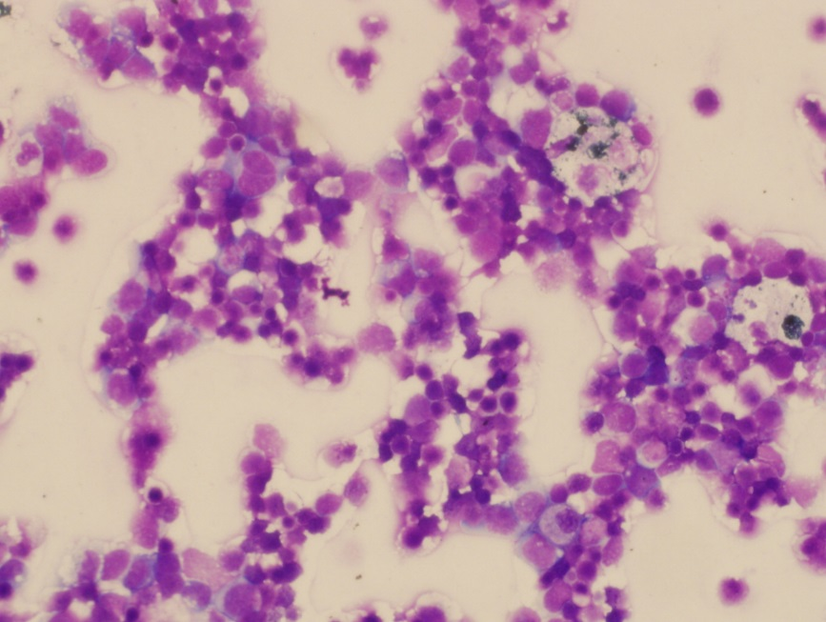

Figure 1: microscopic examination of the aqueous tap from the left eye

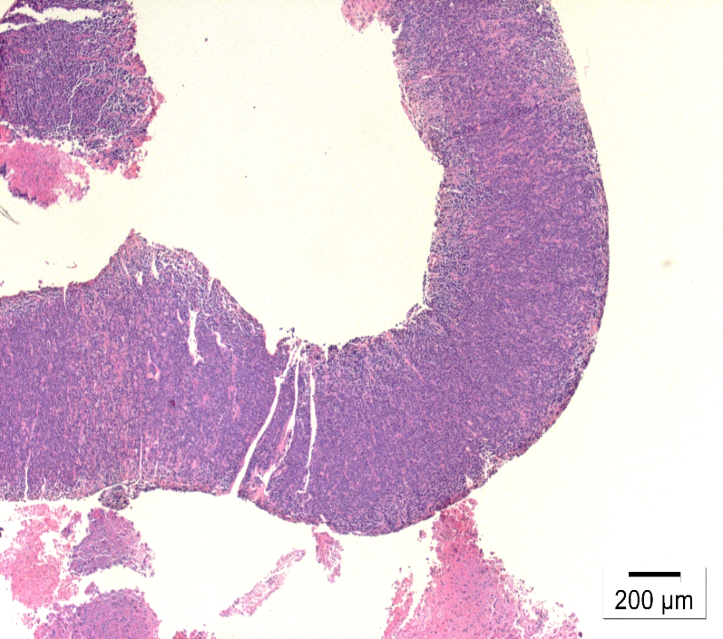
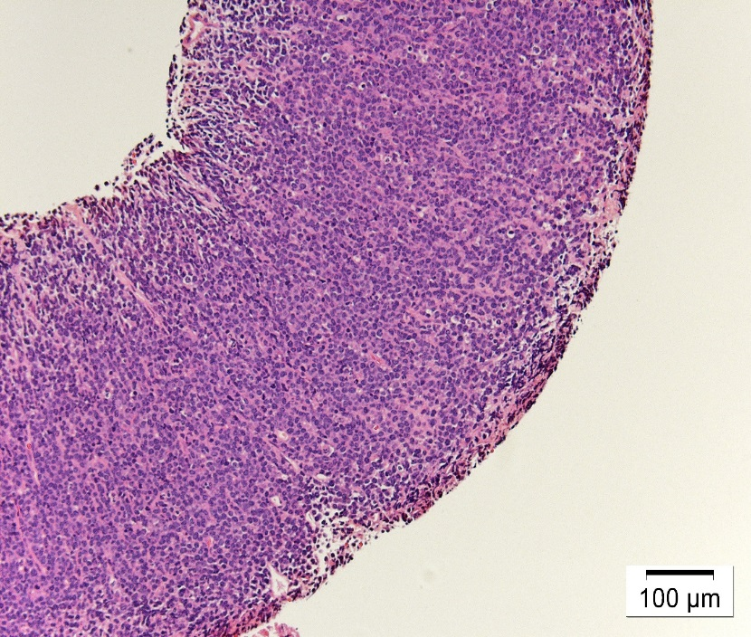
H&E
H&E

Figure 2: Biopsy from from adrenal gland showed adrenal tissue infiltrated with atypical small to medium lymphoid cells with blastoid features.

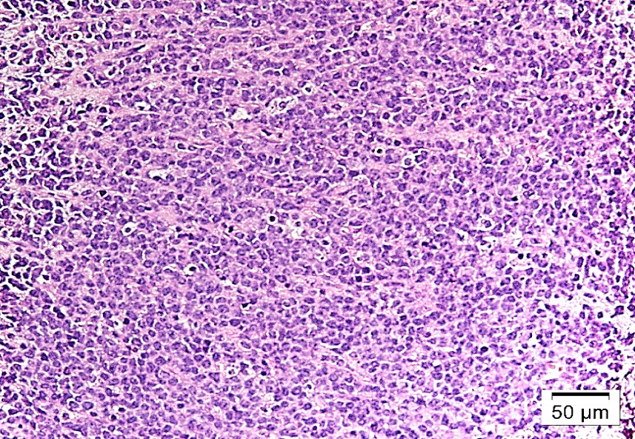
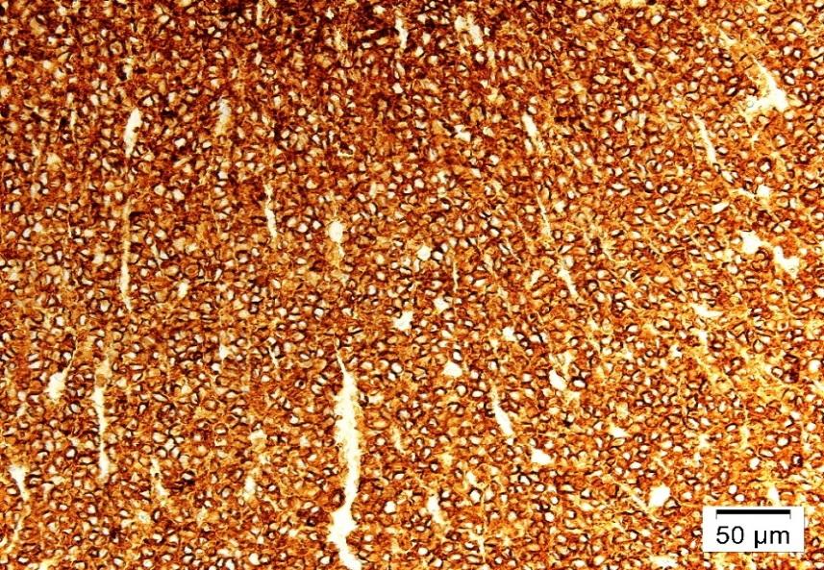
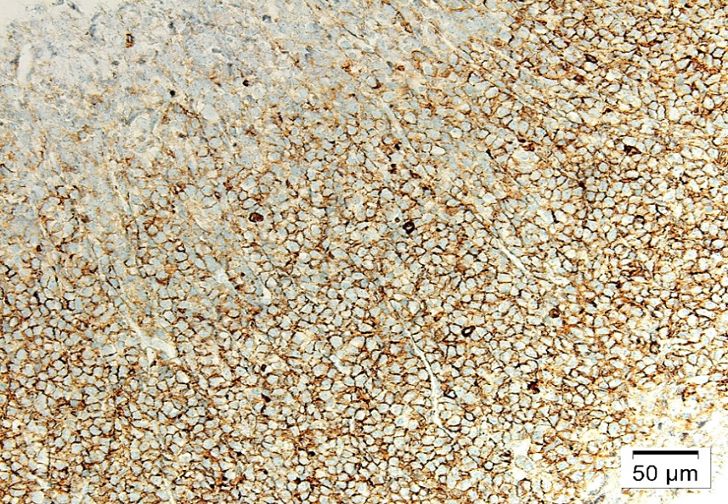
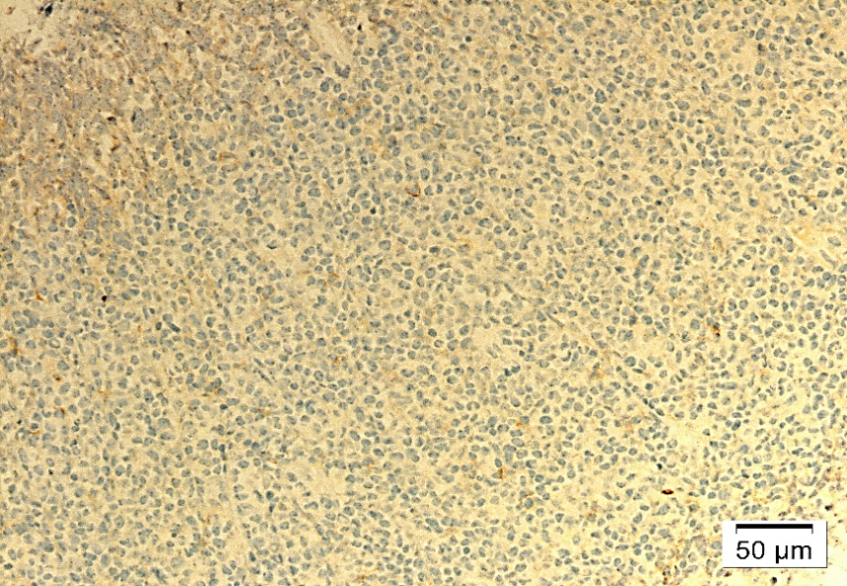

Figure 3: T cell lymphoma confirmed by extensive battery of immunohistochemical stains. Tumor cells were positive to CD 3, CD 34 and negative to CD 20.
H&E
CD3
CD34
CD20

